**2024 CS Maths-2**

Q.1 For positive non-zero real variables x and y, if



then, the value of  is

(A) 1

(B) 1/2

(C) 2

(D) 4

Q.2 A person sold two different items at the same price. He made 10% profit in one item, and 10% loss in the other item. In selling these two items, the person made a total of

(A) 1% profit

(B) 2% profit

(C) 1% loss

(D) 2% loss

Q.3 Let p and q be the following propositions:

p: Fail grade can be given.

q: Student scores more than 50% marks.

Consider the statement: “*Fail grade cannot be given when student scores more than 50% marks.*”

Which one of the following is the CORRECT representation of the above statement in propositional logic?

(A) q → ¬ p

(B) q → p

(C) p → q

(D) ¬ p → q

Q.4 Let f(x) be a continuous function from R to R such that

f(x) = 1 − f(2 − x) Which one of the following options is the CORRECT value of  ?

(A) 0

(B) 1

(C) 2

(D) −1

Q.5 Let A be the adjacency matrix of a simple undirected graph G. Suppose A is its own inverse. Which one of the following statements is always TRUE?

(A) G is a cycle

(B) G is a perfect matching

(C) G is a complete graph

(D) There is no such graph G

Q.6 When six unbiased dice are rolled simultaneously, the probability of getting all distinct numbers (i.e., 1, 2, 3, 4, 5, and 6) is

(A) 1/324

(B) 5/324

(C) 7/324

(D) 11/324

Q.7 Let P be the partial order defined on the set {1,2,3,4} as follows

P = {(x, x) | x ∈ {1,2,3,4}} ∪ {(1,2), (3,2), (3,4)}

The number of total orders on {1,2,3,4} that contain P is __________

Q.8 Let x and y be random variables, not necessarily independent, that take real values in the interval [0,1]. Let z = xy and let the mean values of x, y, z be x̅, y̅, z̅, respectively. Which one of the following statements is TRUE?

(A) z̅= x̅y̅

(B) z̅≤ x̅y̅

(C) z̅≥ x̅y̅

(D) z̅≤ x̅

Q.9 Let A be an n × n matrix over the set of all real numbers R. Let B be a matrix

obtained from A by swapping two rows. Which of the following statements is/are

TRUE?

(A) The determinant of B is the negative of the determinant of A

(B) If A is invertible, then B is also invertible

(C) If A is symmetric, then B is also symmetric

(D) If the trace of A is zero, then the trace of B is also zero

Q.10 Let G be an undirected connected graph in which every edge has a positive integer

weight. Suppose that every spanning tree in G has even weight. Which of the

following statements is/are TRUE for every such graph G ?

(A) All edges in G have even weight

(B) All edges in G have even weight OR all edges in G have odd weight

(C) In each cycle C in G, all edges in C have even weight

(D) In each cycle C in G, either all edges in C have even weight OR all edges in C

have odd weight

Q.11 The number of distinct minimum-weight spanning trees of the following graph

is _________

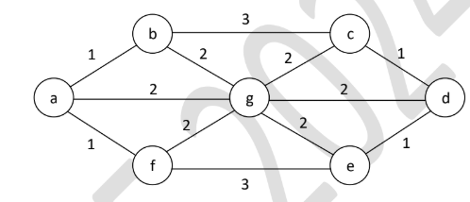

Q.12 The chromatic number of a graph is the minimum number of colours used in a

proper colouring of the graph. The chromatic number of the following graph

is _________

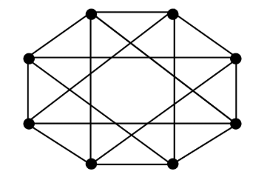

Q.13 Let Zn be the group of integers {0, 1, 2, ... , n − 1} with addition modulo n as the group operation. The number of elements in the group Z2 × Z3 × Z4 that are their own inverses is ________